Faraday Induction
Click to run the simulation below:
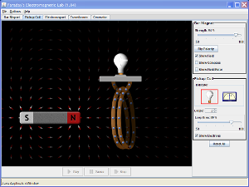
Click to Run

Attributed to:
PhET Interactive Simulations
University of Colorado
http://phet.colorado.edu (Links to an external site.)Links to an external site..

Directions
- Getting started. Open the website listed above and on the top of the screen select the tab marked Pickup Coil.
- Make observations & draw conclusions. Add a field meter to the default screen and drag that field meter so it measures the magnetic field in the middle of the pickup coil. Your screen should look something like what you see to the right, on Screen 1. When the light bulb lights up it indicates the electricity has been generated. Grab the magnet and move it around and observe what happens to the strength of the magnetic field and to the light bulb. Based on your observations what conditions must happen for electricity to be generated.
- Make observations & draw conclusions. Move the magnet back and forth, fast and then slow. What general rule can you make about the speed of the magnet and electrical generation?
- Make observations & draw conclusions. Leave the magnet in just one place and using the button on the right control panel of the applet, flip the polarity of the magnet. Flip the polarity of the magnet fast then slow and observe the amount of electricity that is generated. What general rule can you make about changing the polarity of the magnet and electrical generation?
- Make observations & draw conclusions. Leave the magnet in just one place and using the slide on the right control panel of the applet, change the strength of the magnet. Change the strength fast then slow and observe the amount of electricity that is generated. What general rule can you make about changing the strength of the magnet and electrical generation?
- Draw a conclusion. based on the rules that you developed in steps 2-5, write a general rule about changing magnetic fields and electrical generation.
- Make observations & draw conclusions. Change the number of loops and then generate electricity by changing the magnetic field. What general rule can you make about the number of loops in the pickup coil and electrical generation?
- Make observations & draw conclusions. Change the area of the loop and then generate electricity by changing the magnetic field. What general rule can you make about the area of the loop in the pickup coil and electrical generation?

Apply what you learned
- You are to design a generator to create electricity that produces the maximum amount of electricity possible. Make a list of the different design features you would include in your generator.

